Consequences Magazine

"I could have saved one more" : How complacency kills, and sacrifices save lives
By Noah Alexiou

War memorials embed names of the dead in stone for the rest of eternity. They are an anchor, not only keeping those who lost family attached, but future generations accountable, and aware of the consequences of conflict. However, what can never be recorded are the more subtle, but equally abundant sacrifices. A child's innocence, the soldier's humanity, an elder's wisdom.
These losses aren't just physical, but metaphorical, or epistemic. Sacrifice's like these in texts and media can prompt reflection on our own personal values and moral dilemmas by revealing the extreme choices that arise in life-or-death situations.

'Schindler's Ark', by Thomas Keneally depicts the true story of Oskar Schindler, a WWII industrialist. Between 1938 and 1945 (Echoes & Reflections, 2019), Schindler owned and operated an enamelware and ammunition's factory. Schindler makes a simple but seemingly impossible promise to over 1200 of his Jewish workers, that "If you work here, you'll live through the war".

Death and sacrifice were abundant throughout Schindler's story, not only surrounding him, but among all of those impacted by the war effort. Schindler himself sacrificed his safety, security, and profits for the sake of his Jewish workers. Masses of money and litres of liquor practically flowed from Schindler's pockets and into those of SS Guards, NCO's, Investigators, SS Officials, and hundreds of other powerful men on a regular basis to spare both himself and workers from prosecution and execution. "They don’t have a future, Schindler. That’s not just old-fashioned Jew-hate talking, I assure you. It’s policy." (Keneally, 1982)

Sacrifice is not just a tax for the persecuted and attacked though. Consider for a moment the atrocities committed by SS soldiers. Would you find it easy to kill the innocent at the whim of your superior? Surely they must have sacrificed their humanity by submitting to the brainwashing and propaganda of the Nazi party, else how could they live with themselves, and how else would Jewish children from the ghettos to turn against their own families?

In the darkest hour's of the early morning, German soldiers marched into the ghetto's of Cracow. Foreseeing the inevitable fate that their terminally ill and bedridden patients would be met with, "Doctor H" and "Doctor B" had to face a moral dilemma, choosing to poison their patients, rather than attempt an escape from the ghetto and let them face execution by automatic firearms.

While its easy to think of conflict as an "us VS them" scenario, books like Schindler's Ark can spark discussion that challenges the binary aspect of friend or foe. But what if we consider foe turned friend? What if everything you thought you knew about someone turned out to be a schizophrenic manifestation of indoctrination and propaganda? Would you be willing to sacrifice your previous ideologies aside for someone you love?

Jojo Rabbit, a film written, directed by, and starring Taika Waititi, is a satirical take on WWII from the perspective of Johannes "Jojo" Betzler, a 10 year old boy obsessed with the Nazi regime, and his imaginary friend, Adolf Hitler!
Jojo and 'Imaginary-Hitler' both believe that Jewish people are disgusting and deadly creatures, however when Jojo finds himself face to face with Elsa, a Jewish girl his mother provided with refuge in her home, his only option is to befriend her, lest he face prosecution for harbouring her. Jojo attempts to interrogate Elsa to gain insight on and document the strengths and weaknesses of the "Jews" so he, and the Nazi Party, can be better equipped to take them on. However as he learns more about Elsa and the events that lead her to his home, his feelings of hatred turn to sympathy, and even a little bit of a crush.
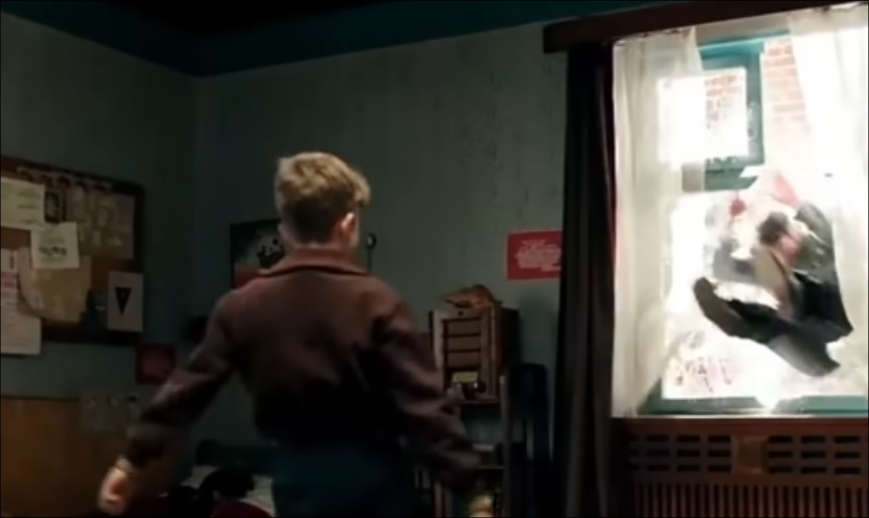(Waititi, 2019)

As a film, Jojo Rabbit is able to reach broader audiences in creative and impactful ways. I strongly believe that as a novel, it would have lacked the immersion and impression that Waititi was able to cultivate, and therefore have seen much less success. In fact, the film was adapted from the novel "Caging Skies", which many viewers may not have heard about until seeing the more accessible Jojo Rabbit. Seeing Hitler fly through a second story window, hearing the gunfire as Captain K and the other soldiers are executed, or feeling the tension in the air as the Gestapo search Jojo's house are all immersive and dynamic scenes that help viewers engage and relate with the characters on a deeper level.

The bright and modern interior of Jojo's house and the colourful streets become a grotesque juxtaposition to the atrocities occurring within them. When we see Jojo's mother lifeless in the town centre, the colour subtly disappears from the world, subconsciously highlighting the magnitude of the loss to viewers, and the climax of consequences that his mother, Rosie Betzler, endured for doing "what they could."

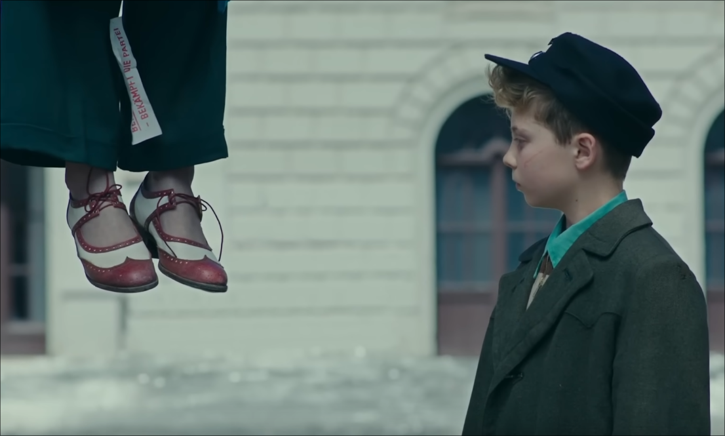(Waititi, 2019)

Returning home, Jojo is met by the Gestapo, who "inspect", or more accurately, ransack his house. Captain K shows up, claiming to have gotten a flat tire while riding his bike, however, he has truly come to help conceal whatever, or whoever, Rosie was hiding, likely as a final request before her execution. When the Gestapo find Elsa, they are rightfully suspicious of her. However, using Jojo's dead sister Inge's Aryan papers, she is able to avoid suspicion when Captain K volunteers to inspect their legitimacy, and despite various inconsistencies, vouches for her legitimacy as an Aryan.

Considering that any sort of rebellion or treason against the Nazi party was a serious offence, and that the Gestapo had just had Jojo's mother hung for spreading Anti-Nazi material, It's safe to say that Captain K's fate would have been sooner rather than later if the Gestapo called his bluff.

After being defeated in battle by the invading Americans, Captain K pulls a ploy on them and manages to convince them that Jojo is Jewish by spitting on him and vociferating that he '\[doesn't\] know \[that\] dirty Jew'. By sealing his fate and expediting his death, Captain K sacrifices his own life for the sake of Jojo's.

These acts of physical sacrifice and rebellion from his superior and mentor create the conditions for Jojo's epistemic sacrifice. Jojo had to sacrifice his previous mindset and prejudices towards the Jewish people in order to embrace the new truth. However, he has great difficulty doing so because, without the information he absorbed from propaganda and 'Hitlers Youths', he wouldn't know what to expect from Elsa. This fear of the unknown kept Jojo from dismissing his previous beliefs and his internal conflict materialises, and climaxes when Jojo has a fight with Imaginary-Hitler, realising that he was a crutch; supportive and comforting in the short term, but nonetheless a burden that prevented Jojo from living the life he deserved, one of a 10 year old boy, not a Nazi.
This may prompt viewers to consider their own beliefs and how willing they are to accept new truths despite their prejudices.

Both Schindler's Ark and Jojo Rabbit change how viewers see war stories by exposing the messy, human elements within them that arise under the circumstances.

Schindler's transformation from Nazi profiteer to saviour demonstrates inherent heroism, the idea that everyone has the potential for heroic actions if they are able to act selflessly in the face of danger. His story shows that while complacency and complicity with the terrible acts committed by the SS was rampant, redemption is possible through costly action.
Jojo Rabbit uses satire to disarm viewers while also juxtaposing absurd humour, like Captain K approaching battle with a cape and tassels, with visceral tragedy, like his execution mere moments later. Jojo's Journey from indoctrinated to empathetic can cause audiences to reflect on whether their biases are taught, rather than innate.

Together, they force us to examine the uncomfortable truth that heroism is hard to come by, and complacency is contagious. We like to think that we would be like Schindler in these situations, however history suggest that we'd probably stand by, averting our eyes like Jojo when his mother takes him to see the executed in the town square. By highlighting how war forces ordinary people to make impossible choices, they reframe sacrifice as not just a noble and righteous endeavour, but a survival tactic.

Literature and film don't just immortalise war stories, they change how we see it's legacy. When Captain K spits on Jojo to save him, or when Schindler cries out, realising that all his possessions are not worth a cent compared to the lives he could have exchanged them for, we are reminded that war's true cost is measured in sacrifices and fractured souls, not just body counts. Our only choices are to be contempt with the horrors we lay witness to, or regret our complacency, just like Schindler, believing that we "could have saved one more..." (Keneally, 1982)

References
Keneally, T. (1982). _Schindler’s ark_. Hodder & Stoughton.

Waititi, T. (Director). (2019). _Jojo rabbit_ [Film]. Fox Searchlight Pictures.

Echoes & Reflections. (2019). _Companion resource to using Schindler's List in the classroom_. Retrieved from [https://echoesandreflections.org/wp-content/uploads/2019/01/Companion_Resource_to_Schindlers_List_Bios.pdf](https://echoesandreflections.org/wp-content/uploads/2019/01/Companion_Resource_to_Schindlers_List_Bios.pdf)

